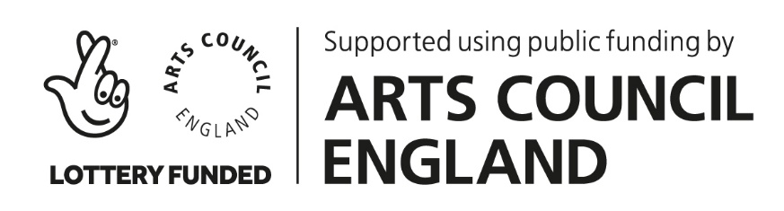
Highland at Home with Hesperi – Week 3
Choreography Challenge
“Jolly Tars” (Hornpipe)

Phrases of 4 counts (2 bars of 4/4)
BASIC
Challenge – adding jumps/elevation throughout

INTRODUCTION
Phrase I * hands akimbo (on hips), standing in 3rd, hold count 1, RF heel beat counts 2-3-4
Phrase II * step to the right, close LF in 1st (hands at sides), salute (right hand), lower arm

A SECTION
Phrase 1 * count 1 & 2 3 & 4
RF inverted toe (corner – 4th Int), heel (turn out corner), RF to 3rd repeat with LF
Arms ~ akimbo

Phrase 2 * 5 & 6 & 7 & 8 &
RF shakes twice to the side, step in front of LF with 2 ‘rocks’ repeat with LF
Arms ~ low behind back

Phrase 3 * 1 2 3 & 4
Crabwalk travelling right – inverted 1st, twist to turnout 1st, invert-turnout-invert
Arms ~ shading (right hand over eyes)

Phrase 4 * slow 5&6&7 quick 5&&a6&&a7 & 8
Heel roll backwards – slow 5 heel steps back RLRLR step up onto the ball LF, RF in 1st position
– quick 9 heel steps back RLRLRLRLR
Arms ~ gathering in

B SECTION * Phrase 5-6

A SECTION * Phrase 9-12

B SECTION * Phrase 13-16

REVERENCE
~ bow/sailor’s salute to finish

You get to invent your own phrases 5-16. You can continue with Hornpipey footwork or freestyle whatever comes out of your feet! We look forward to seeing everyone’s creative choreography.

