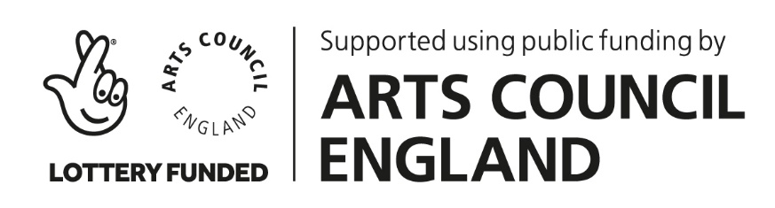
Highland at Home with Hesperi
Week 2 – Fast Feet
“Miss Nancy Frowns” (Jig)

Phrases of 8 counts (4 bars of 6/8)
BASIC
Challenge

INTRODUCTION
~ stand for 4 counts, bow for 4 counts
OR ~ step to right and curtsey (counts 1-4), step back to the left & rise on the balls of the feet

A SECTION
Phrase 1 * skip change of step right-left, assemble (right), spread 2nd, assemble (left), change (right front)
Phrase 2 * pas de basque right-left, 4 high cuts lifting left-right-left-right (turn to the right)

B SECTION (Flora McDonald’s Fancy – 1st step)
Phrase 3 * hop-brush-beat-beat (twice right foot)
spring onto right – left goes behind – extend to the left corner, repeat with the right foot
Phrase 4 * point left in 2nd, take it behind right leg, hop-brush-beat-beat left (turn to the right)
4 springs pointing right-left-right-left

C SECTION
Phrase 5 * hop & travel left foot (twice), bouree derriere (behind-side-behind) from left, then from right
Phrase 6 * pas de basque left-right (turn to the left to face the back)
skip change of step left-right (finishing where you started, facing front)

B SECTION ON THE LEFT
Phrase 7&8 * repeat section B – but with the other foot (starting left)

REVERENCE
~ curtsey/bow to finish

