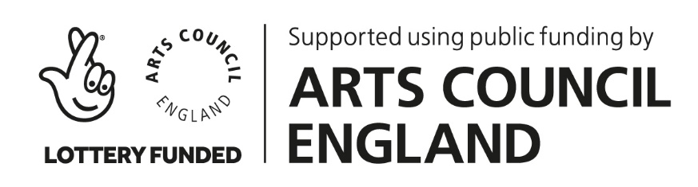
Highland at Home with Hesperi – Week 1
“Braes of Elchies” (Jig)

We are counting in phrases of 8 counts (4 bars of 6/8)

BASIC
MODIFIED (low impact – no jumps, no arms)
Challenge (extra turns)

Introduction
Stand for 4 counts, bow for 4 counts

Section A
Phrase 1 * pas de basque right-left, 4 springs pointing left-right-left-right
Phrase 2 * pas de basque right-left, 4 high cuts lifting left-right-left-right
Phrase 3 * pas de basque right-left (turn to the right), shedding LEFT foot
Phrase 4 * pas de basque left-right (turn to the left), shedding RIGHT foot

Section B
Phrase 5 * travelling to the right side ~ step right close left, 2 hops, step left close right, 2 hops
(or 2 strathspey steps right-left) replace hops with 2 marches
Phrase 6 * 4 toe-heels right-left-right-left
Phrase 7 * travelling to the left side ~ step left close right, 2 hops, step right close left, 2 hops
(or 2 strathspey steps left-right) replace hops with 2 marches
Phrase 8 * pas de basque left-right (turn to the left), 4 high cuts lifting right-left-right-left

Reverence
Bow to finish

